Eligibility form for athletes with an
Intellectual Impairment.

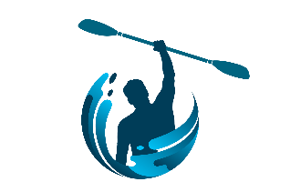
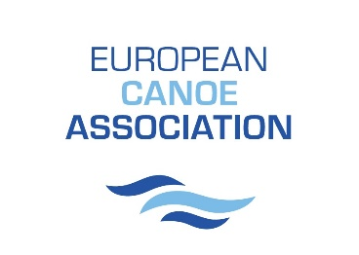
For Exhibition Events at the
2024 ECA Canoe Sprint,
Paracanoe and Stand Up Paddling
Championships

Please attach passport style photo of athlete here

Athlete Name

Athlete Date of Birth

Athlete Federation

Name and Title of Health Care Professional completing this form, example Dr or Consultant
(Please Print)

Does the athlete have a lifelong permanent Intellectual Impairment? YES NO

Please state the name of the Impairment, example Down’s Syndrome?

Was the Impairment Diagnosed before the athlete reached 18 yrs old? YES NO

Is the Impairment severe enough to impact on all aspects of the athletes daily living, for example the ability to care for themselves or to travel independently? YES NO

Does the athlete have any other Disabling Conditions, for example Visual or Hearing Impairments, Epilepsy? YES NO
If YES, what are they? (Please List )

Is the athlete considered fit to participate in the level of physical activity involved in paddling? YES NO

Date
Signature of Health Care Professional Completing this Form

